V5 LOGISTICS AND WAREHOUSING
Daily Demand Planning & Vehicle Allocation Optimization for ATM Distribution
Internship project report: operations, coordination and improvement framework

Item | Detail
Prepared by | Mahir Valani, Intern, V5 Logistics and Warehousing
Subject area | Third-party logistics: primary, secondary and last-mile transportation of ATM machines
Report type | Internship project report (PGDM/MBA submission and operations review)
Evidence basis | Operational account from the internship; no company records, financial data or external benchmarks used

This report documents work performed, outcomes recalled by the intern, and recommendations proposed by the analyst. Recommendations are proposals and are not claimed to have been implemented. The reported cycle-time improvement is a recollection and has not been independently verified.

Contents
1 Cover Page
2 Executive Summary
3 Company and Operational Context
4 Project Background
5 Problem Statement
6 Project Objectives
7 Scope and Limitations
8 Methodology and Evidence Standards
9 End-to-End Transportation Process
10 Daily Demand Planning and Vehicle Allocation
11 Role and Contribution of the Intern
12 Key Operational Challenges
13 Root-Cause Analysis
14 Reported Cycle-Time Improvement
15 Load Utilization and Cost-Control Opportunities
16 KPI Framework
17 Proposed Standard Operating Procedures
18 Recommendations
19 Implementation Roadmap
20 Expected Operational Benefits
21 Limitations and Data Requirements
22 Conclusion
23 Appendices

Evidence labels used throughout
• Reported: information from the internship operational account.
• Calculated: arithmetic on reported figures (e.g. the cycle-time reduction).
• Analyst interpretation: reasoned explanation of reported challenges.
• Proposed: recommendation not confirmed as implemented.
• Unavailable: data needed before a firm conclusion is possible.

2 Executive Summary
V5 Logistics and Warehousing handles third-party transportation of ATM machines through three linked stages: primary (inbound to a warehouse), secondary (warehouse to district-level vendors or distribution points) and last-mile (final delivery to the bank or installation site). The operations team coordinated approximately 150+ consignments daily across these stages, working from delivery requirements received by email.
Execution depended on more than assigning vehicles. Delays were linked, in the operational account, to late communication between the logistics team, vendors and banks, to unconfirmed site readiness (closed banks, absent representatives, unarranged lifting equipment), to multiple handling stages, and to machine damage. Some delayed consignments incurred vehicle-holding charges; the exact amounts are unavailable.
150+  Daily consignments (team level)  Across primary, secondary and last-mile; not machines or vehicles | 3  Transportation stages  Primary, secondary, last-mile | ≈10 → ≈4–5 days  Reported operational cycle  Intern recollection; subject to validation
50–60%  Calculated reduction  (10−5)÷10 and (10−4)÷10 | 10  Recommendations  Proposed, not implemented | 10  KPIs defined  Baseline to be established

What was done, what is reported, what is proposed
Category | Summary
Work performed (reported) | The intern supported daily demand planning, consolidation of compatible orders, vendor coordination, vehicle allocation, site-readiness coordination, follow-up of pending confirmations and exception handling, alongside another intern and a team of about four to five.
Reported outcome | The operational cycle reduced from about 10 days to about four to five days (50–60%). Cycle boundaries and records are unavailable, so this is not independently verified and no single cause is claimed.
Analyst proposals | Standard order-intake template; pre-dispatch site-readiness checklist; consolidated daily plan; vendor tracker; compatible-load consolidation; exception and holding-charge register; delivery calendar; damage and proof-of-delivery process; Tier 1 and S&OE action tracker; KPI dashboard.
Not available | Holding-charge amounts, vehicle capacities, utilisation, damage rates, transportation cost, machine counts, delivery success rates and any validated baseline.
No financial benefit is quantified in this report because historical cost data are unavailable.
Management takeaway
The reported improvement is encouraging, but it cannot yet be validated or sustained without defined cycle events, consistent timestamps and a shared planning and exception record. The next step is to formalise planning and measurement, starting with the order-intake template, the site-readiness checklist and a shared daily plan.

3 Company and Operational Context
V5 Logistics and Warehousing operates third-party logistics activities that include the transportation and distribution of ATM machines. Bhiwandi was an important warehouse and coordination point in the operating network; other warehouse locations could be relevant depending on the movement. Not every consignment passed through every location.
Figure 1. Primary, secondary and last-mile transportation stages
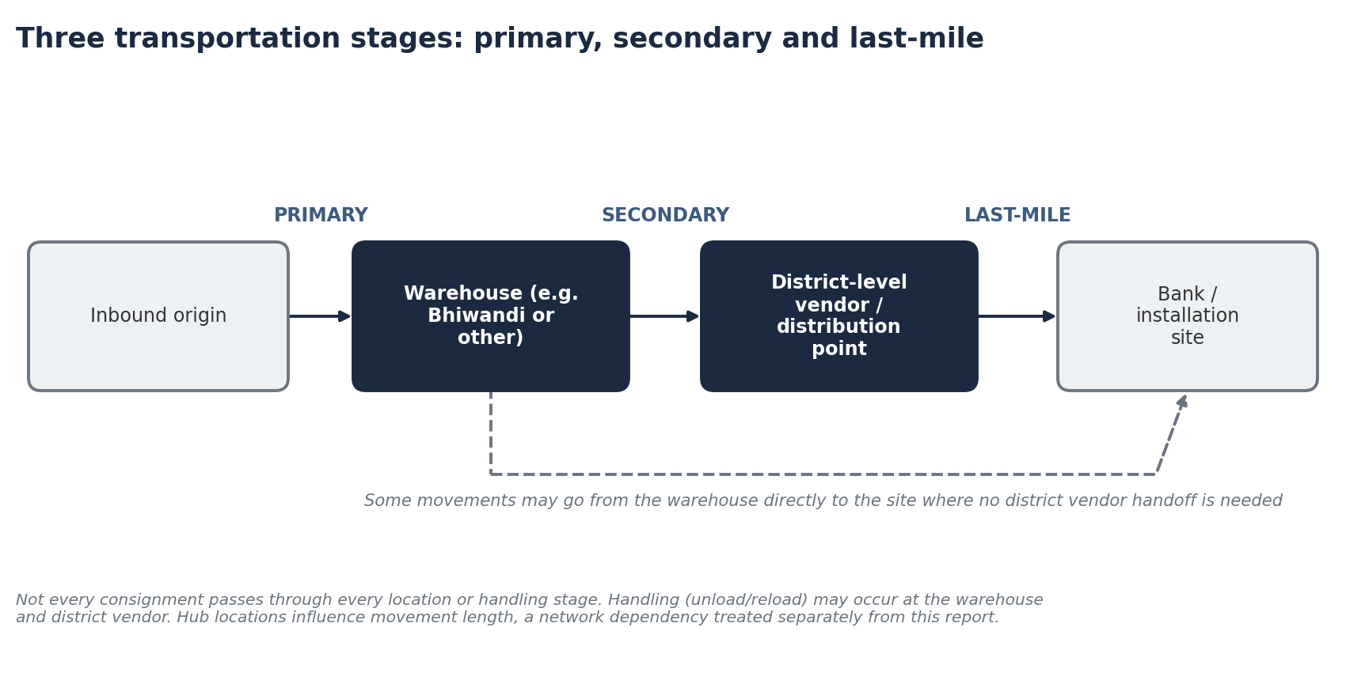
Source: operational account; schematic by analyst. Not every consignment follows every stage.
Stage | Movement | Typical coordination need
Primary | Inbound movement of machines to the designated warehouse | Inbound vehicle arrangement; warehouse receiving
Secondary | Warehouse to district-level vendors or relevant distribution points | Vendor and vehicle confirmation; consolidation; dispatch timing
Last-mile | Final delivery to the designated bank or installation site | Site readiness; receiving arrangements; proof of delivery

4 Project Background
The operations team received delivery requirements by email. An illustrative requirement might ask for 20 ATM machines to be distributed across 10 locations; smaller orders could involve 10–20 machines, or only four to five. These examples illustrate the nature of the planning problem and are not verified historical orders.
The team coordinated order requirements, inventory availability, vehicle allocation, district-level vendors, delivery schedules, site readiness and final delivery. During the internship, two interns supported coordination across the three stages, working with a broader team of roughly four to five members. Responsibilities were shared and members assisted each other when required.
Clarification on the workload figure
The approximate 150+ figure refers to consignments handled daily across the team's transportation operation. It does not describe machines, vehicles, vehicle capacity, or deliveries completed by each intern.

5 Problem Statement
Daily execution required the simultaneous coordination of many consignments with different quantities, destinations, vendors, deadlines and site requirements. Transportation could be delayed not by a lack of vehicles but by information and readiness gaps: unconfirmed site availability, late communication of holidays or receiving arrangements, unplanned lifting needs and avoidable handling steps. Delays could lead to holding charges on some consignments, and damaged machines required additional exception handling.
Problem statement: how can V5 plan demand and allocate vehicles daily so that compatible consignments are consolidated, site readiness is confirmed before dispatch, exceptions are managed visibly, and performance is measured consistently, without sacrificing delivery commitments?

6 Project Objectives
Objective | Nature of coverage in this report
Understand the end-to-end ATM transportation process | Documented (Section 9)
Examine daily demand planning and order consolidation | Documented and framework proposed (Section 10)
Document vehicle allocation and vendor coordination practices | Documented and framework proposed (Sections 10, 11)
Explain consolidation of compatible consignments to improve load utilization | Analyst framework (Sections 10, 15)
Examine coordination between primary, secondary and last-mile stages | Documented (Sections 3, 9)
Identify communication failures and delivery-readiness issues | Reported challenges (Section 12)
Analyse the reported cycle-time reduction | Reported and calculated (Section 14)
Relate improved coordination, fewer delays and holding-charge exposure | Analyst interpretation, qualitative (Sections 14, 15)
Develop recommendations, KPIs and SOPs | Proposed (Sections 16–19)
Not every objective produced a separately measured improvement. Work performed, recalled outcomes and analyst recommendations are kept distinct.

7 Scope and Limitations
In scope: the process of planning and executing ATM transportation across the three stages; coordination practices; reported challenges; the reported cycle-time change; and proposed recommendations, KPIs and SOPs.
Out of scope: the detailed Bhiwandi versus Kolhapur network comparison, which belongs to a separate network-optimisation project; freight-rate negotiation; financial evaluation. The absence of a Kolhapur hub at the time is noted only as a network dependency that lengthened some movements, and is not treated as the cause of the reported cycle-time improvement.
Principal limitations: no company records were available; the cycle-time boundaries are undefined; vehicle capacities, holding charges, damage rates and volumes are unknown; and meeting agendas, attendance records and formal escalation rules were not provided. Details are in Section 21.

8 Methodology and Evidence Standards
The report is built from the intern's operational account, structured into a problem statement, process maps, root-cause analysis and a proposal framework. No external benchmarks, surveys, interviews or citations are used; none are implied.
Category | Meaning | Example in this report
A Reported operational facts | Provided in the internship account | 150+ daily consignments; site-readiness issues
B Calculated results | Arithmetic on provided figures | 50–60% cycle-time reduction
C Analyst interpretation | Reasoned explanation of reported challenges | Link between unconfirmed readiness and holding charges
D Proposed improvements | Not confirmed as implemented | Order-intake template; dashboard
E Unavailable information | Must be collected | Holding charges; capacity; baselines

9 End-to-End Transportation Process
The as-is flow below reflects the documented operating model. Conditional branches show that machines already in warehouse stock skip inbound transportation, and that specialised unloading, bank holidays or absent representatives, damage and delays apply only to some consignments.
Figure 2. As-Is process flow with conditional branches
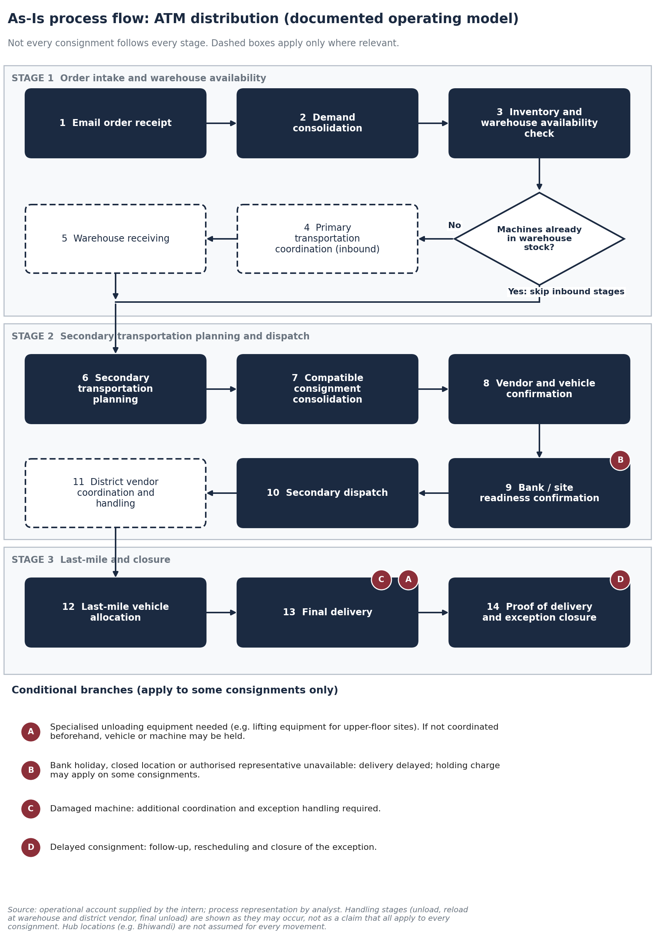
Source: operational account; flow drawn by analyst.

Handling stages
Depending on the movement, handling may include unloading at a warehouse, reloading for secondary transportation, unloading at a district vendor, reloading for last-mile delivery and final unloading at the site. Each stage adds a coordination requirement and an opportunity for avoidable delay. Not every stage can or should be eliminated; the aim is to reduce unnecessary movements and improve coordination while preserving necessary handling.

Proposed To-Be process
The To-Be flow is a recommendation. It moves readiness checks earlier, uses one shared plan, adds vendor-confirmation and escalation deadlines, and introduces structured exception and KPI review.
Figure 3. Proposed To-Be process flow
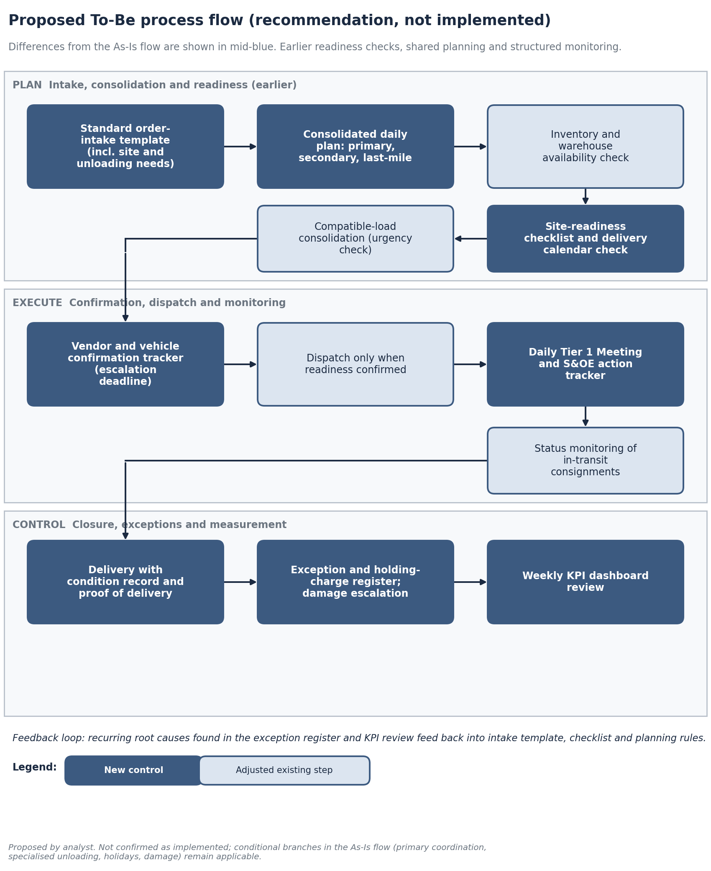
Source: analyst proposal; not implemented.

10 Daily Demand Planning and Vehicle Allocation
Daily cadence. The team held a Tier 1 Meeting / Daily Huddle and S&OE (Sales and Operations Execution) reviews. These are distinct from S&OP and are not interchangeable. Daily operational reviews can support prioritisation, vehicle confirmation, vendor coordination, resolution of pending issues and monitoring of delivery commitments. Exact agendas, attendance and escalation rules are unavailable, so the practices below are proposed.
Forum | Proposed use (not a documented agenda)
Tier 1 Meeting / Daily Huddle | Short start-of-day review of today's consignments, unconfirmed vehicles and vendors, readiness gaps and blocked deliveries; assign owners.
S&OE | Execution-focused review of in-progress consignments, delays, exceptions and next-day commitments; decide escalations.

Consolidation logic
Combining compatible consignments can improve load utilisation, but it is not always appropriate. The planner weighs destination and geographic compatibility, district-vendor coverage, usable vehicle capacity, consignment quantities, deadlines and sequencing, machine availability at the warehouse, site readiness, handling requirements and the risk of delaying an urgent consignment by pairing it with an incompatible order.
Consolidate when | Do not consolidate when
Destinations lie on a compatible corridor | Corridors are incompatible or detours would be needed
Combined quantity fits usable capacity (to be confirmed) | Combined quantity or handling needs exceed what the vehicle can carry
Deadlines align or the later one is not threatened | An urgent consignment would wait for others
Sites are ready and vendors available | Any site readiness is unconfirmed
Figure 4. Proposed daily allocation decision flow
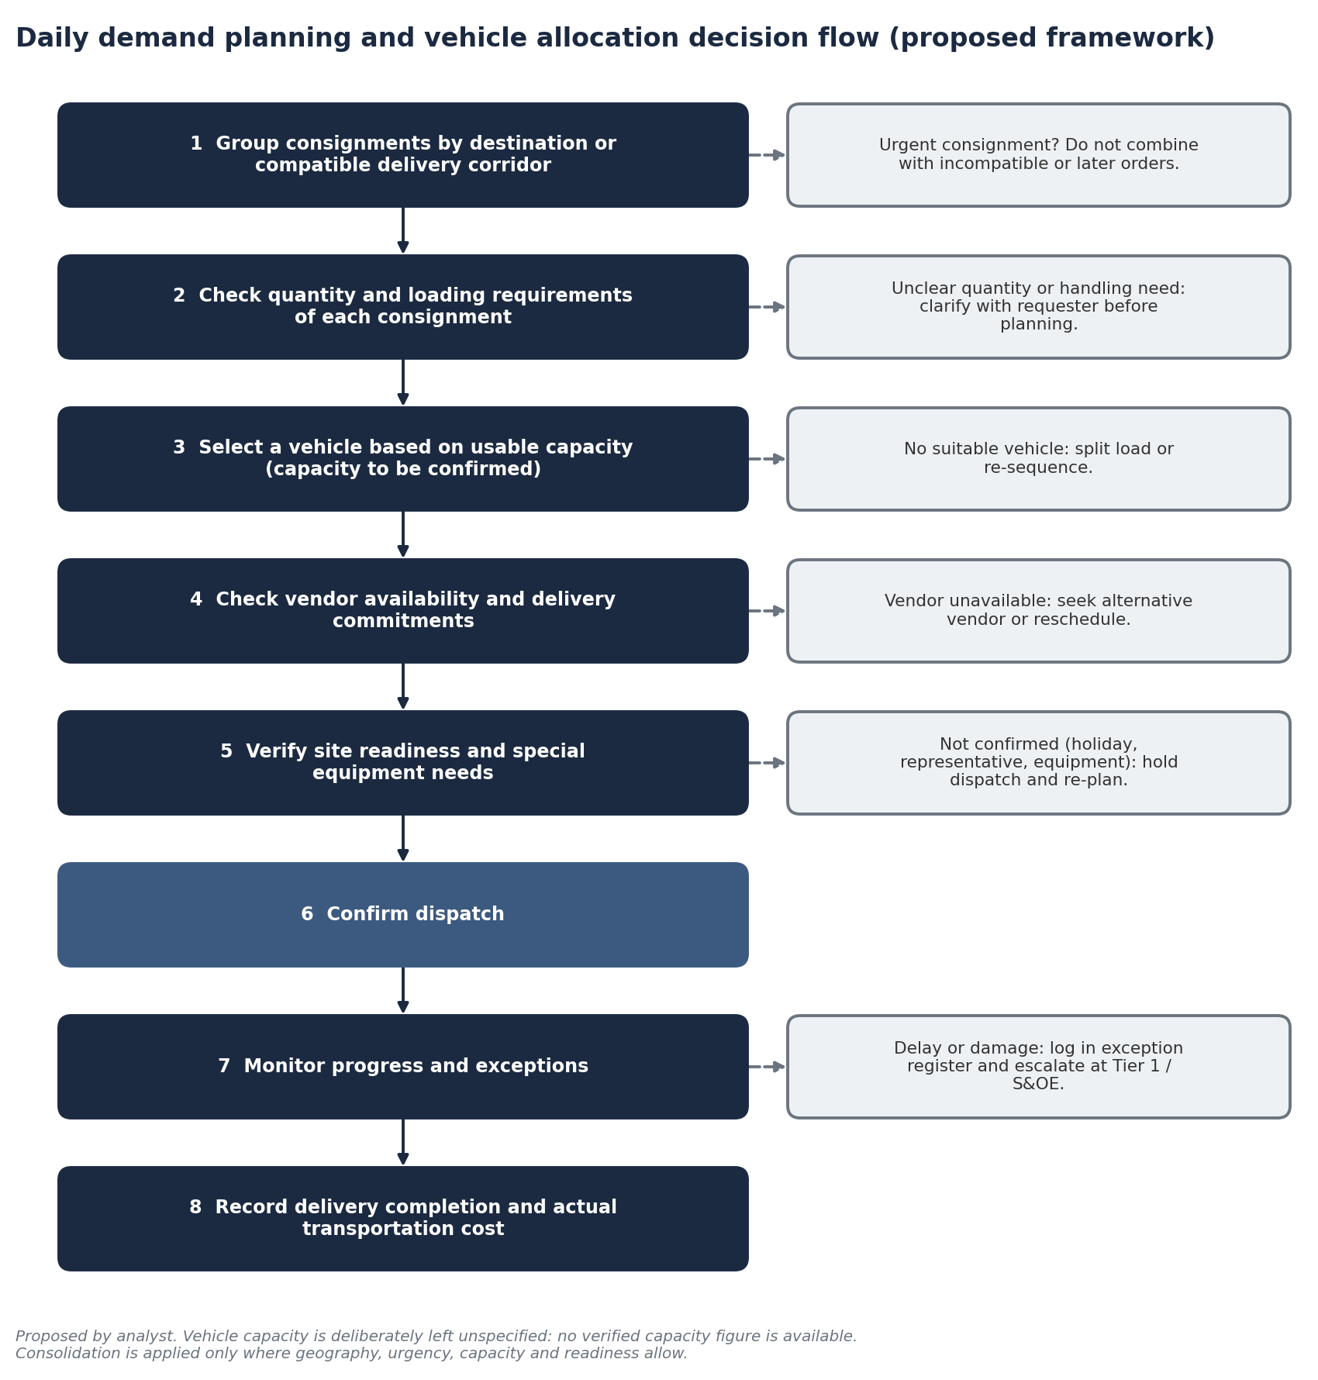
Source: analyst proposal. Vehicle capacity figures are to be confirmed.
Illustrative example (not a verified order)
A requirement of 20 machines for 10 locations would first be grouped by district or delivery corridor. The number of vehicle movements then follows from corridor compatibility, usable capacity and deadlines, rather than from a fixed rule. Capacity is not specified here because no verified figure is available.

11 Role and Contribution of the Intern
The intern worked collaboratively with another intern and the wider operations team. The activities below are described as support and coordination; final authority over dispatch decisions, expenditure approval and freight rates rested with the team and management.
Area | Intern's contribution (reported) | Team / management level
Three-stage coordination | Supported coordination across primary, secondary and last-mile | Overall plan and priorities set by the team
Demand planning and consolidation | Supported daily planning; combined compatible orders where feasible, considering destination, vendor coverage, capacity and deadlines | Final allocation and approvals
Vendor coordination | Coordinated with district-level vendors through the day | Commercial terms and rates
Vehicle allocation and delivery planning | Supported vehicle allocation and planning | Dispatch authority
Site readiness | Coordinated receiving arrangements and readiness | Escalation with banks
Follow-up and exceptions | Followed up pending confirmations and delays; helped manage exceptions | Decisions on charges and responsibility
Cost awareness | Supported a cost-conscious approach to delivery execution | Cost decisions and quotations
The intern did not independently manage the operation, approve expenditure, negotiate every freight rate or personally generate financial savings.

12 Key Operational Challenges
Challenge | Description (reported)
A High daily coordination workload | About 150+ consignments daily across the three stages, each with different quantities, locations, vendors, deadlines and site requirements.
B Fragmented communication | Gaps between the logistics team, vendors and banks sometimes delayed execution; availability, site readiness, holidays and receiving arrangements were not always communicated early enough.
C Site readiness and receiving arrangements | Some sites, such as upper floors in malls or commercial buildings, could require lifting equipment (a JCB was mentioned as an example, depending on the site). Uncoordinated needs could hold the vehicle or machine.
D Bank holidays and unavailable representatives | Delivery could be delayed if the bank was closed, the location unavailable or an authorised representative absent, showing that planning is more than a vehicle problem.
E Multiple handling stages | Unloading and reloading at the warehouse and district vendor and unloading at the site created coordination needs and opportunities for avoidable delay.
F Vehicle-holding charges | Some, not all, consignments incurred holding charges when vehicles or deliveries were delayed. Exact historical figures are unavailable.
G Machine damage and exceptions | Damage required additional coordination and exception handling. No damage rate is claimed.
H Network constraint | The absence of a Kolhapur hub at the time lengthened some movements. This is a context dependency only; the Bhiwandi–Kolhapur analysis is a separate project.
Source: operational account supplied by the intern.

13 Root-Cause Analysis
The fishbone on the next page groups causes into categories. Each cause is tagged: (R) reported in the operational account, (A) analyst interpretation, (H) hypothesis requiring validation. They are not confirmed findings.

Figure 9. Root-cause fishbone
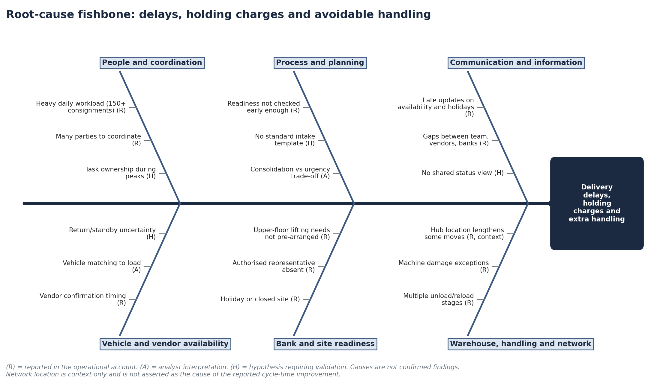
Source: operational account (R); analyst interpretation (A); hypotheses requiring validation (H).

5 Whys: delays caused by site unavailability
Why? | Answer | Evidence
1 Why was the delivery delayed? | The site or representative was unavailable, or the bank was closed. | Reported
2 Why was this not avoided? | Availability and holidays were not confirmed before dispatch. | Reported (communication gaps)
3 Why not confirmed earlier? | Readiness checking was not a fixed pre-dispatch step and information arrived late. | Analyst interpretation
4 Why was information late? | No standard way to capture site and receiving requirements at order intake. | Hypothesis
5 Why no standard capture? | Planning focused on vehicle assignment under heavy daily workload. | Hypothesis
Root cause (hypothesis): readiness confirmation is not embedded as a standard pre-dispatch step. Validate through the exception register.

5 Whys: vehicle-holding charges from inadequate readiness confirmation
Why? | Answer | Evidence
1 Why were holding charges incurred? | Vehicles waited or deliveries were delayed on some consignments. | Reported
2 Why did vehicles wait? | The site could not receive the machine (closed, no representative, no lifting equipment). | Reported
3 Why dispatched anyway? | Readiness was not verified or not communicated before dispatch. | Analyst interpretation
4 Why not verified? | No checklist or confirmation gate before the dispatch decision. | Hypothesis
5 Why no gate? | Confirmations were handled informally across several parties. | Hypothesis
Root cause (hypothesis): no formal readiness gate before dispatch. Not every consignment incurred holding charges.

14 Reported Cycle-Time Improvement
The intern recalls that the relevant operational cycle reduced from approximately 10 days to four to five days. This is a reported operational improvement recalled by the intern, not an independently verified company-wide result. The precise start and end events of the cycle, and the underlying historical records, are unavailable, so the metric is referred to as the reported operational cycle time and is not labelled order-to-delivery, order-to-dispatch or lead time.
Scenario | Earlier cycle | Later cycle | Reduction | Percentage reduction
Scenario A | 10 days | 5 days | 5 days | 50%
Scenario B | 10 days | 4 days | 6 days | 60%
Formula: (Baseline cycle time − new cycle time) ÷ baseline cycle time × 100. Calculated from reported figures.
Figure 5. Reported operational cycle time before and after
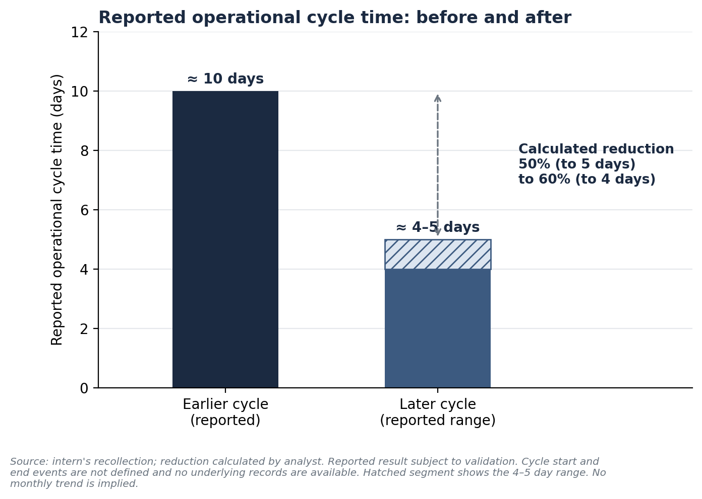

Interpretation and cautions
- Plausible link (analyst interpretation): earlier readiness confirmation, clearer vendor confirmations and consolidated planning can shorten waiting between steps, and fewer delays reduce exposure to vehicle-holding charges. This is a hypothesis, not a proven mechanism.
- No single cause is claimed. The reduction cannot be attributed to one intervention, to the team's coordination alone, or to any network change.
- Kolhapur hub: its absence at the time is context. The improvement is not attributed to a new hub.
- No invented data: no monthly trend, sample size, significance test or audit result is shown.
- To validate: capture timestamps for order receipt, planning completion, vehicle confirmation, dispatch and final delivery under an agreed cycle definition.

15 Load Utilization and Cost-Control Opportunities
Load utilisation compares actual load to usable vehicle capacity. No verified capacity or load data exist, so no utilisation percentage is calculated. The opportunities below are qualitative.
Opportunity | How it may help | Condition / trade-off
Compatible-load consolidation | Fewer partially filled movements | Only where geography, urgency and readiness allow
Earlier readiness confirmation | Reduces vehicle waiting and holding exposure | Requires reliable information from banks and sites
Shared daily plan | Avoids duplicate or conflicting vehicle requests | Needs consistent updates
Vendor confirmation with escalation deadline | Shortens uncertainty on district movements | Depends on vendor responsiveness
Reducing unnecessary handling | Fewer touch points and delay opportunities | Necessary handling must be preserved
Recording actual cost per consignment | Enables cost per machine tracking | Needs finance data

Vehicle-holding charges
Holding charges arise when a vehicle or delivery is delayed, for example because a bank is closed, a representative is absent or lifting equipment is not arranged. They did not apply to every consignment. Prevention measures are readiness confirmation before dispatch, a delivery calendar for holidays, early communication of receiving requirements and exception tracking. No baseline, percentage reduction or rupee saving is stated, as the historical figures are unavailable.

16 KPI Framework
Ten KPIs are proposed. Historical values are not available except the recalled cycle-time comparison. Detailed definitions (data, why it matters, corrective actions) are in Appendix A and the workbook.
KPI | Formula | Owner | Frequency | Historical value
A Operational cycle time | End timestamp − start timestamp (define events first) | Operations lead | Daily / weekly | Reported ≈10 → ≈4–5 days
B On-time delivery rate | Deliveries in agreed window ÷ total due × 100 | Last-mile coordinator | Daily / weekly | Data unavailable
C Vehicle utilization | Actual load ÷ usable capacity × 100 (same unit) | Planning lead | Weekly | Data unavailable
D Consolidation rate | Eligible consignments combined ÷ total eligible × 100 | Planning lead | Weekly | Data unavailable
E Site-readiness confirmation | Confirmed before dispatch ÷ planned deliveries × 100 | Last-mile coordinator | Daily | Data unavailable
F Vehicle-holding cost | Total charges; charges ÷ affected consignments | Finance + operations | Monthly | Data unavailable
G Cost per machine | Recorded cost ÷ machines transported | Finance + operations | Monthly | Data unavailable
H Damage rate | Damaged ÷ handled × 100 | Warehouse supervisor | Monthly | Data unavailable
I Vehicle confirmation lead time | Confirmation − order receipt | Planning lead | Daily / weekly | Data unavailable
J First-attempt success | First-attempt successes ÷ planned deliveries | Last-mile coordinator | Weekly | Data unavailable
Owners are proposed roles, not confirmed assignments. Historical values must not be inferred.

Figure 6. KPI dashboard template (placeholders only)
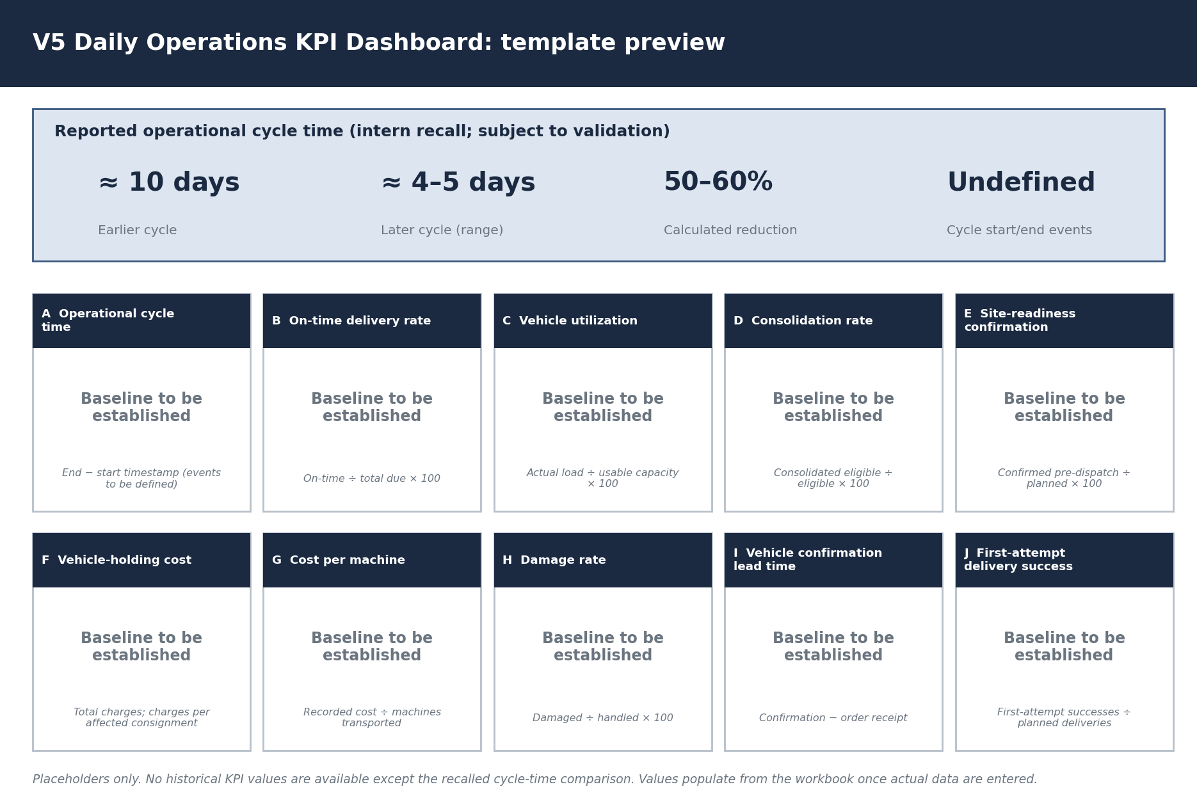
No historical KPI values are shown except the reported cycle-time comparison.

17 Proposed Standard Operating Procedures
The SOPs below are proposed for management review. They are not formal V5 policies and none is claimed to be in force.
SOP | Trigger | Key steps | Owner (proposed) | Record
SOP-1 Order intake | On receipt of an email order | Record order ID, quantity, destination, required date, vendor, site contact, receiving requirements and special unloading needs in the template; flag incomplete orders | Planning coordinator | Intake template
SOP-2 Daily planning and consolidation | Start of day / after Tier 1 | Group consignments by corridor; check quantity and loading needs; select vehicle by usable capacity; apply urgency check before combining | Planning lead | Consolidated daily plan
SOP-3 Pre-dispatch readiness | Before every dispatch decision | Confirm bank open, representative available, site access, unloading requirements and equipment; hold dispatch if any item is not confirmed | Last-mile coordinator | Readiness checklist
SOP-4 Vendor and vehicle confirmation | After planning | Request confirmation, record contact and expected arrival, set escalation deadline, escalate unconfirmed items at Tier 1 / S&OE | Vendor coordinator | Confirmation tracker
SOP-5 Exception and holding-charge handling | On any delay or hold | Log cause, duration and responsible party where established; record charge from finance; escalate; close with resolution | Operations lead | Exception register
SOP-6 Damage and proof of delivery | At handover points | Record machine condition, capture delivery confirmation, escalate damage and track to resolution | Warehouse supervisor / last-mile coordinator | Condition record; POD
SOP-7 Tier 1 and S&OE cadence | Daily | Review pending decisions, owners, deadlines, vehicle confirmations and delayed consignments; update action tracker | Operations lead | Action tracker

18 Recommendations
Ten recommendations are prioritised by implementation effort, expected operational benefit and dependency. Timelines are indicative relative durations for discussion, not commitments. None is claimed to have been implemented.
# | Recommendation | Effort | Expected benefit | Priority | Dependency
1 | Standardised order-intake template | Low | High | 1 | None
2 | Pre-dispatch site-readiness checklist | Low | High | 1 | Template (1)
3 | Consolidated daily transportation plan | Medium | High | 1 | Template (1)
4 | Vendor confirmation tracker | Low | Medium–High | 2 | Plan (3)
5 | Compatible-load consolidation | Medium | Medium–High | 2 | Plan (3), capacity data
6 | Exception and holding-charge register | Low | Medium–High | 2 | Finance cooperation
7 | Bank holiday and delivery calendar | Low | Medium | 2 | Bank/site information
8 | Damage and proof-of-delivery process | Medium | Medium | 3 | Warehouse cooperation
9 | Daily Tier 1 and S&OE action tracker | Low | Medium–High | 1 | Plan (3)
10 | Transportation performance dashboard | Medium | High (long term) | 3 | Baseline data from 1–9
Effort, benefit and priority are preliminary qualitative judgements by the analyst.

1 Standardised order-intake template
Field | Detail
Problem addressed | Missing or late site and receiving information at order stage
Proposed action | Capture order ID, quantity, destination, required date, vendor, site contact, receiving requirements, special unloading needs
Implementation steps | Draft template; agree mandatory fields; pilot on incoming emails; review gaps weekly
Responsible role (proposed) | Planning coordinator
Priority | 1 (high)
Suggested timeline | Weeks 1–2 (indicative)
KPI for effectiveness | % of orders with complete intake data (supports KPI E)
Dependencies / risks | Adoption by requesters; incomplete emails

2 Pre-dispatch site-readiness checklist
Field | Detail
Problem addressed | Holds from closed banks, absent representatives, unarranged equipment
Proposed action | Confirm bank status, representative, access, unloading needs and equipment before dispatch
Implementation steps | Define checklist; require sign-off before dispatch; escalate unconfirmed items
Responsible role (proposed) | Last-mile coordinator
Priority | 1 (high)
Suggested timeline | Weeks 1–3
KPI for effectiveness | KPI E: site-readiness confirmation rate
Dependencies / risks | Bank/site responsiveness

3 Consolidated daily transportation plan
Field | Detail
Problem addressed | Fragmented visibility across stages
Proposed action | One shared sheet for primary, secondary and last-mile with vehicle, quantity, destination, vendor, dispatch, deadline, status
Implementation steps | Build from tracker template; update at Tier 1; one owner per row
Responsible role (proposed) | Planning lead
Priority | 1 (high)
Suggested timeline | Weeks 2–4
KPI for effectiveness | KPI I; KPI A
Dependencies / risks | Discipline of updates

4 Vendor confirmation tracker
Field | Detail
Problem addressed | Late or unknown vendor confirmations
Proposed action | Record confirmation status, contact, expected arrival, escalation deadline
Implementation steps | Log each request; escalate at deadline; review at S&OE
Responsible role (proposed) | Vendor coordinator
Priority | 2 (medium)
Suggested timeline | Weeks 3–5
KPI for effectiveness | KPI I: vehicle confirmation lead time
Dependencies / risks | Vendor cooperation

5 Compatible-load consolidation
Field | Detail
Problem addressed | Under-filled movements
Proposed action | Combine orders where geography, capacity, commitments and readiness allow
Implementation steps | Apply allocation flow; urgency check; record eligibility and outcome
Responsible role (proposed) | Planning lead
Priority | 2 (medium)
Suggested timeline | Weeks 4–8
KPI for effectiveness | KPI D, KPI C
Dependencies / risks | Verified capacity data; urgency conflicts

6 Exception and holding-charge register
Field | Detail
Problem addressed | Unrecorded delays and charges
Proposed action | Record delay, root cause, duration, responsible party where established, charges
Implementation steps | Log in register; link finance records; review weekly
Responsible role (proposed) | Operations lead with finance
Priority | 2 (medium)
Suggested timeline | Weeks 3–6
KPI for effectiveness | KPI F; repeat cause count
Dependencies / risks | Access to finance data

7 Bank holiday and delivery-calendar management
Field | Detail
Problem addressed | Deliveries attempted on closed days
Proposed action | Maintain validated delivery calendar; confirm exceptions before dispatch
Implementation steps | Compile holidays and site closures; check before planning
Responsible role (proposed) | Last-mile coordinator
Priority | 2 (medium)
Suggested timeline | Weeks 2–4
KPI for effectiveness | KPI J; holds from closures
Dependencies / risks | Calendar accuracy

8 Damage and proof-of-delivery process
Field | Detail
Problem addressed | Damage handled ad hoc
Proposed action | Record condition at handovers, capture delivery confirmation, escalate and track damage
Implementation steps | Define condition record; require POD; track resolution
Responsible role (proposed) | Warehouse supervisor
Priority | 3 (medium)
Suggested timeline | Weeks 5–8
KPI for effectiveness | KPI H: damage rate
Dependencies / risks | Consistent recording

9 Daily Tier 1 and S&OE action tracker
Field | Detail
Problem addressed | Pending decisions not tracked
Proposed action | Record pending decisions, owners, deadlines, vehicle confirmations, delayed consignments, resolution
Implementation steps | One tracker; review each meeting; close actions
Responsible role (proposed) | Operations lead
Priority | 1 (high)
Suggested timeline | Weeks 1–2
KPI for effectiveness | Action closure rate (supports KPI A, B)
Dependencies / risks | Meeting discipline

10 Transportation performance dashboard
Field | Detail
Problem addressed | No consistent measurement
Proposed action | Track cycle time, on-time delivery, utilisation, consolidation, holding charges, damage with actual data
Implementation steps | Define KPIs; build baseline; review weekly
Responsible role (proposed) | Operations lead / analyst
Priority | 3 (long term)
Suggested timeline | Weeks 8+
KPI for effectiveness | All KPIs A–J
Dependencies / risks | Needs reliable data from 1–9

19 Implementation Roadmap
Figure 7. Proposed implementation roadmap
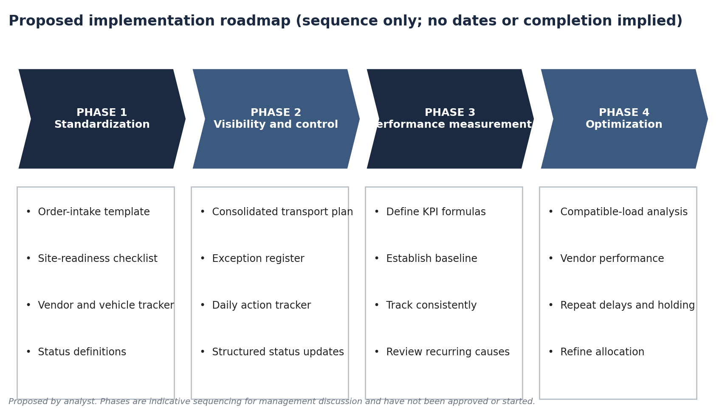
Proposed only. Presented as sequence; no dates or completion implied.
Phase | Actions | Exit criterion (proposed)
1 Standardization | Order-intake template; site-readiness checklist; vendor and vehicle confirmation tracker; consignment status definitions | Templates in daily use
2 Visibility and control | Consolidated plan; exception register; daily action tracker; structured status updates | One shared view of all consignments
3 Performance measurement | Define KPI formulas; establish reliable baseline; track consistently; review recurring root causes | Baseline established for each KPI
4 Optimization | Analyse compatible-load consolidation; evaluate vendor performance; examine repeat delays and holding charges; refine allocation and sequencing | Evidence-based refinements

Risk and mitigation
Figure 8. Implementation risk matrix (preliminary)
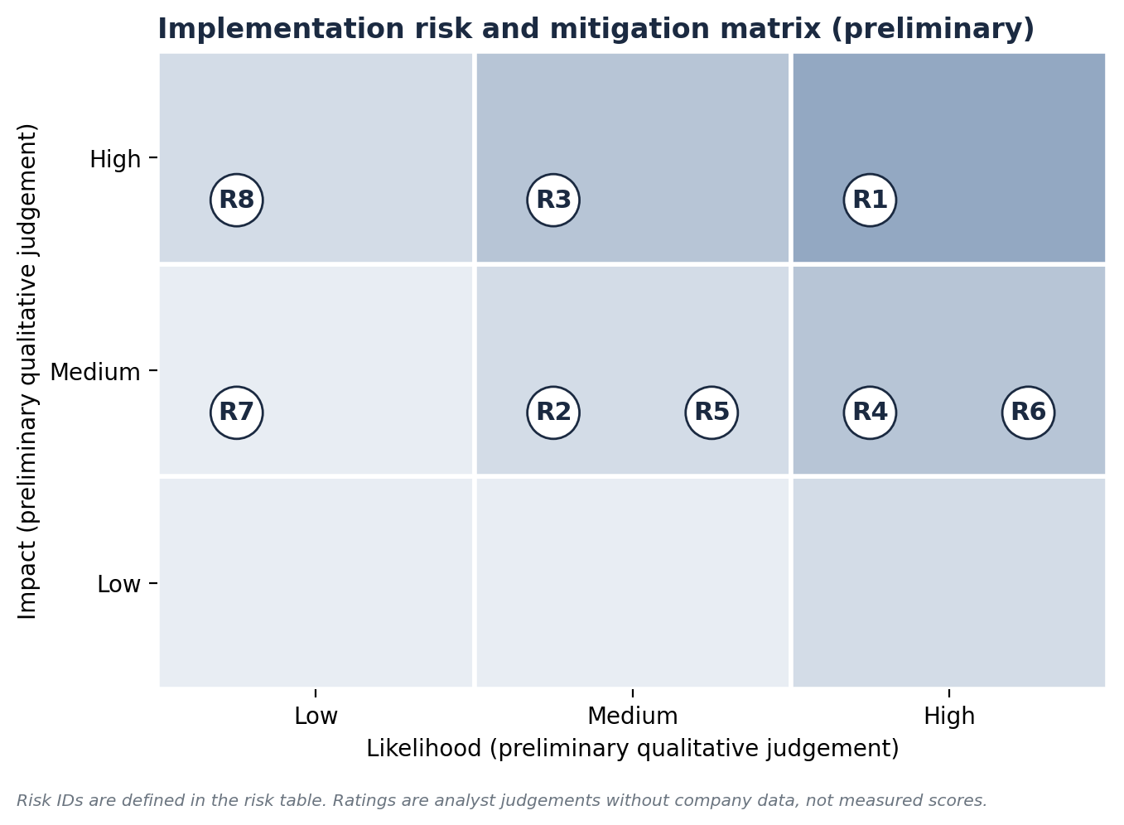
Preliminary analyst judgement; not measured.
ID | Risk | Mitigation | Impact / likelihood (prelim.)
R1 | Incomplete data capture prevents a baseline | Mandatory fields; daily owner; start with fewest fields | High / High
R2 | Team workload limits adoption of trackers | Start with templates that replace existing messages; Tier 1 reinforcement | Medium / Medium
R3 | Vendors do not respond to confirmation deadlines | Escalation deadline; alternative vendor list | High / Medium
R4 | Bank or site information unavailable | Early outreach; delivery calendar; escalate unconfirmed sites | Medium / High
R5 | Over-consolidation delays urgent consignments | Urgency check in allocation flow | Medium / Medium
R6 | Trackers become out of date | Single owner per row; review at Tier 1 | High / Medium
R7 | KPI definitions disputed | Agree and document definitions before measuring | Medium / Low
R8 | Network location limits achievable cycle improvement | Treat as dependency; assess in separate network project | High / Low
Ratings are preliminary qualitative assessments without company data.

Responsibility matrix (RACI, proposed)
Activity | Ops lead | Planning lead | Coordinators / interns | Vendor coord. | Warehouse sup. | Finance
Order-intake template | A | R | C | I | I | I
Daily consolidated plan | A | R | R | C | C | I
Pre-dispatch readiness | A | C | R | I | C | I
Vendor/vehicle confirmation | A | C | R | R | I | I
Exception and holding register | A | C | R | C | C | R
Damage and POD | A | I | R | I | R | I
Tier 1 / S&OE | A/R | R | R | C | C | I
KPI dashboard | A | R | C | C | C | R
R = Responsible, A = Accountable, C = Consulted, I = Informed. Proposed roles for discussion; not confirmed V5 assignments.

20 Expected Operational Benefits
The benefits below are expected and qualitative. None is quantified because no baseline exists, and none is claimed as achieved.
- Fewer avoidable holds from closed or unprepared sites, and reduced exposure to holding charges.
- Better visibility across primary, secondary and last-mile movements.
- More deliberate use of compatible-load consolidation, with urgency safeguards.
- Faster, tracked vendor and vehicle confirmation.
- Consistent exception, damage and proof-of-delivery records.
- A basis for validating and sustaining the reported cycle-time improvement.

21 Limitations and Data Requirements
Unavailable item | Data needed
Cycle-time definition and records | Agreed start/end events; timestamps for order receipt, planning completion, vehicle confirmation, dispatch, final delivery
Holding charges | Finance records by consignment and cause
Vehicle capacity and load | Verified usable capacity and actual load per trip, in one unit
Damage | Condition records at handovers; machines handled
Transportation cost | Recorded cost by component and consignment
Volumes | Machines and consignments handled by stage and period
Delivery performance | Agreed windows, actual delivery, first-attempt outcomes
Meeting practices | Tier 1 and S&OE agendas, attendance, escalation rules
No external benchmarks or sources were used. No figures here should be read as V5 performance beyond the reported items stated.

22 Conclusion
Daily ATM transportation execution depends on more than assigning vehicles. Accurate demand consolidation, timely primary transportation, efficient secondary transportation, compatible-load consolidation, vendor and vehicle coordination, bank and site readiness, last-mile execution, exception management and performance measurement all interact. A gap in any one, such as an unconfirmed site, can hold a vehicle regardless of how well the load was planned.
The operational cycle reportedly reduced from approximately 10 days to four to five days, a calculated 50–60% reduction. This is a recollection, the cycle's start and end events are undefined, and no records are available, so it should be treated as a promising but unverified indication rather than a validated result. No financial impact is claimed.
The next step is to formalise planning and measurement: standardise intake and readiness checks, keep one shared plan and exception register, define the cycle, and capture consistent timestamps so improvements can be validated and sustained.

23 Appendices

Appendix A KPI detail
KPI | Definition | Formula | Required data | Owner / frequency | Why it matters | Corrective action
A Operational cycle time | Elapsed time between defined start and end events | End − start timestamp | Start/end timestamps (events to define) | Ops lead; daily/weekly | Shows end-to-end responsiveness | Find longest stage; fix recurring cause
B On-time delivery rate | Deliveries inside agreed window | Within window ÷ total due × 100 | Planned, actual time, window | Last-mile coordinator; daily/weekly | Direct service measure | Analyse late deliveries by cause
C Vehicle utilization | Load versus usable capacity | Actual load ÷ usable capacity × 100 | Verified capacity, actual load (same unit) | Planning lead; weekly | Reveals under-filled movements | Review consolidation and vehicle choice
D Consolidation rate | Eligible consignments moved in shared vehicles | Combined eligible ÷ total eligible × 100. Eligible = compatible corridor, no urgency conflict, readiness confirmed, capacity available | Eligibility and shared-movement flags | Planning lead; weekly | Shows use of opportunities | Review non-consolidated eligible items
E Site-readiness confirmation | Readiness confirmed before dispatch | Confirmed before dispatch ÷ planned deliveries × 100 | Confirmation and dispatch times | Last-mile coordinator; daily | Prevents avoidable holds | Enforce checklist; escalate
F Vehicle-holding cost | Recorded holding charges | Total charges; charges ÷ affected consignments | Finance records; consignment IDs | Finance + ops; monthly | Quantifies cost of delay | Target repeat causes
G Cost per machine | Recorded cost per machine | Recorded cost ÷ machines transported (state components) | Invoices; machine counts | Finance + ops; monthly | Cost control | Review high-cost lanes
H Damage rate | Machines recorded damaged | Damaged ÷ total handled × 100 | Condition records; counts | Warehouse supervisor; monthly | Quality and exception load | Root-cause by stage
I Vehicle confirmation lead time | Order receipt to confirmation | Confirmation − order receipt (not cycle time) | Two timestamps | Planning lead; daily/weekly | Early planning indicator | Escalate delays at Tier 1 / S&OE
J First-attempt success | Deliveries successful first time | First-attempt successes ÷ planned deliveries | Attempt count | Last-mile coordinator; weekly | Captures repeat visits | Review failures by reason

Appendix B Glossary
Term | Meaning in this report
Tier 1 Meeting / Daily Huddle | Daily operational review at team level
S&OE | Sales and Operations Execution: execution-focused review (distinct from S&OP)
Primary / Secondary / Last-mile | Inbound to warehouse / warehouse to district vendor or distribution point / final delivery to site
Consignment | A unit of order handled in the transportation operation (not a machine count)
Holding charge | Charge on some delayed vehicles or deliveries; amounts unavailable
POD | Proof of delivery

Appendix C Workbook guide
V5_Daily_Operations_KPI_Dashboard.xlsx contains KPI definitions, tracker templates (consignments, vehicle allocation, vendors, site readiness, exceptions), a cycle-time sheet and a dashboard that shows "Baseline to be established" until data are entered. Input cells are blue; formulas are grey. The only populated figures are the reported cycle-time comparison.

Appendix D Evidence register
Statement | Type
150+ consignments daily across the team | Reported
10 days → ≈4–5 days | Reported
50–60% reduction | Calculated
Plausible link between coordination, fewer delays and holding exposure | Analyst interpretation
All recommendations, SOPs, KPIs, roadmap, RACI | Proposed
Holding charges, capacity, utilisation, damage, cost, volumes | Unavailable

